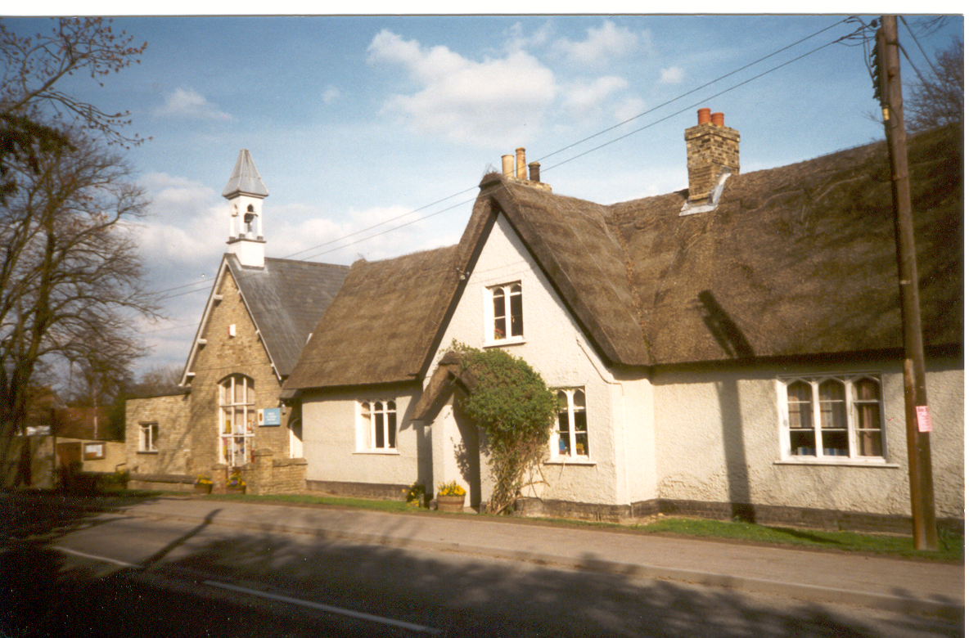
Belonging, Believing; Together Succeeding!
2023 - 2024
BARRINGTON
CHURCH OF ENGLAND
(VOLUNTARY CONTROLLED)
SCHOOL
Welcome to Barrington Church of England (VC) Primary School. You and your child are joining us at an exciting time, with the completion of the school build in September 2019 and the gradual increase in the number of classes as families move into the new development in the village. Despite this increase in size, we are determined to ensure that we maintain everything that makes our school special. Our school motto, Belonging, Believing; Together, Succeeding, exemplifies everything that we strive to achieve. Our most recent Ofsted reports include the comments, “Pupils at Barrington C of E Primary School are confident, kind and happy.”(2022)”There is a delightful atmosphere in school. You and your staff go the extra mile to make sure that school is not only about learning in lessons. You provide a wide range of clubs which make school exciting and fun.” (2017) We hope this brochure gives you a flavour of the school; our warm, caring and inclusive atmosphere and academic success, the wide variety of extra-curricular experiences offered, and the dedication and commitment of all our staff.

Your family are about to start an exciting journey with us and we are looking forward to many happy years together as your child grows and learns. As with any journey, the secret to success is in the preparation. There are lots of things you will need to know and many steps we will take together to help you get ready for the autumn term. This brochure should provide the majority of the information you will need to get started, but please feel free to come into school and ask any additional questions you may have – there is no such thing as a silly question!

Here at Barrington we strongly emphasise the importance of community, caring for one another and supportive learning in a nurturing and stimulating environment. Our overall aim is to develop each child as an individual; socially, emotionally, physically, spiritually and academically by providing a happy, secure and creative environment. Our aim is for children to enjoy their time at Barrington; for us to help them to increase their self-confidence and to develop a love of learning, enabling each child to reach his or her full potential.

Family involvement in a child’s education is proven by research to be one of the most important factors for a successful educational experience. Barrington actively seeks out volunteers and plans regular activities to support family learning. You are on this journey too!

The information in this brochure applies to the current school year. The particulars are correct at the date of publication, but it cannot be guaranteed that there will be no changes affecting admissions arrangements.

We aim to work with an open door policy and make every effort to provide face to face contact whenever you need us. Should you have any query regarding your child’s education or welfare, please do not hesitate to come in and speak to a member of staff.

Whether you have something positive that you would like to share or would like to discuss a concern, please come and talk to me – you can catch me most mornings outside at the entrance off the playground – or can email me if you would prefer (head@barrington.cambs.sch.uk)

I look forward to getting to know you and your children in the coming weeks.
Yours sincerely,

Gill Davies

Mrs Gill Davies
Headteacher

CONTENTS

Aims of the School Page 4
Important contact information Page 5
What is a Voluntary Controlled School? Page 6
Our Staff Page 7
Term dates Page 8
Our School Governors Page 9
General Information and Transport to School Page 10
Our 'Home School' Partnership, homework Page 11
Community links Page 12
Class Organisation Page 13
Admissions Policy Page 13
Special Educational Needs and Accessibility Page 14
More Able Pupils Page 15
Positive Behaviour Page 16
Attendance Page 17
Education Welfare Page 19
School Meals and snacks Page 19
School Curriculum Pages 20 - 28
Complaints Pages 28
Key Stage Test Results Page 29 - 30
Ofsted Page 31 - 35
School Activities Page 36
Pastoral Care Pages 37 - 40
School Clothing and Uniform Page 40
Friends of Barrington School (FOBS) Page 42
The Peacock club Page 43

Barrington Church School Aims

Our vision, deeply rooted in a strong Christian tradition, is to develop happy, young people with enquiring minds, a lifelong love of learning, respect for themselves, others and the environment, so that they will have the skills, resilience and adaptability to thrive in a rapidly changing world.

The aim of Barrington School is to provide a happy, safe and stimulating atmosphere where:
· Christian values are promoted
· Respect for others and personal responsibility are expected
· Children enjoy learning and are confident and willing to try
· High academic standards are encouraged and the needs of every
child are met
· Teachers, parents and carers work together as partners in
their children’s education
· Foundations for lifelong learning are established
· Children develop independent learning skills
· Community spirit is fostered

Key Christian Values
Our school values are central to our spiritual development and our school is a place where:
- There is an ethos of care and concern which embraces all members of the school community.
(Key Christian value – Christian love)
- We aim to include everyone and be loyal and supportive friends.
(Key Christian value - Friendship)
- Creativity – we value and celebrate new ideas and ways to express ourselves.
(Key Christian value – Creativity)
- Truth – we endeavour to be truthful to ourselves and to others.
(Key Christian value – Truth)
- We trust each other and believe in the honesty and reliability of others.
(Key Christian value – Trust)
- We challenge ourselves to be the best we can be and to face our fears.
(Key Christian value –Courage)
- Forgiveness – we forgive each other and do not bear a grudge, so that we can live together happily. (Key Christian value – Forgiveness)
- We aim for inner peace; learning how to be calm and contented, coping with anxieties and fears, and also for peace between each other in school; making and keeping friends, sorting out arguments, making compromises, letting go of hostile feelings and learning how to listen to each other.
(Key Christian value – Peace)
Addresses for your reference

Barrington Church of England (Voluntary Controlled) Primary School
Haslingfield Road
Barrington
Cambridge
CB22 7RG
Tel: 01223 712273
Fax: 01223 712276
Email: office@barrington.cambs.sch.uk www.barrington.cambs.sch.uk

Director of Learning
Service Director for Learning is Jonathan Lewis
Jonathan.Lewis@cambridgeshire.gov.uk
CC1001
Shire Hall
Cambridge
CB3 0AP
Telephone: 01223 507165

Local Secondary School to which the children normally transfer

Melbourn Village College St Bede’s Inter Church School
The Moor Birdwood Road
Melbourn Cambridge
Nr Royston Cambs
Herts
SG8 6EF CB1 3TP
Tel: 01763 223400 01223 568816
Email: office@mvc.org.uk office@stbedes.cambs.sch.uk

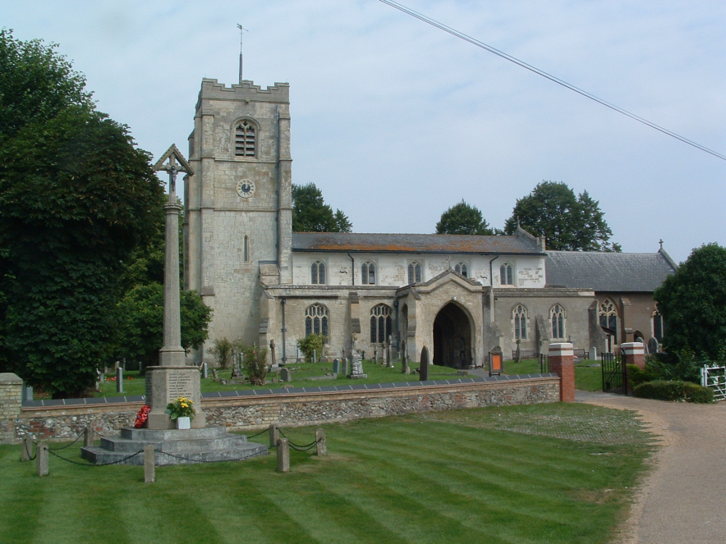
What is a Voluntary Controlled School?

Voluntary Controlled schools were originally set up by voluntary bodies, such as the Church of England, and have important links with these bodies. ‘Voluntary Controlled’ schools are totally funded by the Local Education Authority (LEA), which employs the staff. The LEA is also responsible for admissions. The school governing body controls the use of the school premises, but have to follow general rules set by the LEA.

Recognising its historic foundation, the school aims to preserve and develop its religious character in accordance with the principles of the Church of England and in partnership with the Church at parish and diocesan level.

As a Church of England school, Christianity forms the basis of our daily acts of collective worship. These are held both in school and in the Church.
RE is intended to be suitable for all our pupils. It benefits pupils by increasing their understanding and awareness of other people and their ability to respect the rights of others even where they disagree with their views. It contributes to pupils' spiritual, moral and ethical development. It is designed to be of educational worth to all pupils from any or no religious background.

The governing body includes three ‘Foundation’ Governors, appointed by the Ely Diocesan Board of Education.

As a church school we also have regular SIAMs inspections. Our latest inspection in February 2020 rated the school as outstanding. Here are some quotes from their report. If you would like to read more the full report is on the school website;

“A relentless focus by leaders on the Christian vision and values ensures they are at the heart of this vibrant and caring school. Deeply embedded, these values imbue everything the school does.”

“The school has an outward looking approach. Links with local societies such as the British Legion have allowed pupils to consider sacrifice. Local history work gives pupils a real sense of belonging, enhancing their understanding of the school motto.”

“The caring and nurturing environment, directly attributable to core Christian values, has a significant impact on pupils and their families. The harmonious atmosphere that is immediately apparent is created by a hard-working team who wholeheartedly support and recognise leaders’ aspirations for the school.”

“Staff have a real sense of the overarching love that permeates the school.”

“Pupils’ social and personal development is a real strength. Behaviour is consistently good in all areas of school and, when out of school, pupils know what it means to make good choices because of the embedded values.”

“As a result of feeling cherished and loved, all strive to do their best. Highly individual tailored support enables the most vulnerable to make impressive progress. Staff know all pupils exceptionally well.”

“Partnerships with like-minded schools have resulted in a grant to develop oracy, making a significant impact on pupils. As a result, they are all able to give reasoned opinions, leading to excellent discussions. Together with an exceptional ministries approach to pupil voice, pupils play a significant part in the development of the school. They are incredible agents for change in many areas of life and are flourishing.”

Staff List from September 2023

Mrs Gill Davies | Headteacher
Miss Claire Fonseka | Teacher - Violet Class (Year 6, 3 days)
Mrs Laura Hadley | Teacher - Violet Class (Year 6, 2 days)
Mrs Lucy Mcgregor | Teacher - Blue Class (Year 4 & 5, 3 days)
Mrs Abi Carridge | Teacher - Blue Class (Year 4 & 5, 2 days)
Miss Beth Meredew | Teacher – Green Class (Year 3 )
Mrs Yvette Beswick | Teacher – Yellow Class (Year 2, 3 days )
Mrs Liz Kershaw | Teacher Yellow Class (Year 2, 2 days)
Mrs Andrea Avant | Senior Teacher – Orange Class (Year 1)
Mrs Clair Hayes | Senior Teacher – Red Class (Reception Year)
Mr Johnny Herd | Specialist Sports Coach - PE Teacher
Mrs Janice Nussey | Teacher – SEN (1 day)
Mrs Teresa Alderton | Teaching Assistant & Lunchtime Supervisor
Mrs Helen Brammar | Teaching Assistant
Mrs Debbie Burge | Teaching Assistant & Peacock Club
Mrs Dulcie Cambridge | HLTA & Peacock Club Manager
Miss Haidee Cambridge | Lunchtime Supervisor & Peacock Club & Teaching Asst.
Mrs Gemma Evans | Teaching Assistant
Mrs Clare Mayling | Teaching Assistant & Lunchtime Supervisor
Miss Dee McCabe | Higher Level Teaching Assistant
Mrs Kirstie Purse | Lunchtime Supervisor
Mrs Susan Richards | Teaching Assistant & Lunchtime Supervisor
Mrs Hayley Rivers | Teaching Assistant & Lunchtime Supervisor
Mrs Julie Wiseman | Teaching Assistant
Mrs Catherine Worthington | Teaching Assistant & Lunchtime Supervisor
Mrs Rachel Bream | Finance Officer
Mrs Julia Lindley | School Secretary
Mr James Phillips | Caretaker
Ms Sian Douglas | Caretaking team
Miss Trudi Betts | School Cook
Miss Sharon Connor | Catering Assistant & Caretaking team
Mrs Josie Cambridge-Flack | Netball club
School term dates 2023 - 2024

including training days

New Reception Pupils will have phased entry in September

AUTUMN TERM 2023
Training day* Friday 1st September 2023
Term Starts Monday 4th September to Wednesday 20th December 2023
Half term: Monday 23rd October to Friday 27th October 2023
Training day* Monday 30th October 2023

SPRING TERM 2024

Term Starts: Thursday 4th January to Thursday 28th March 2024
Training day* Friday 26th January 2024
Half term: Monday 19th February to Friday 23th February 2024

SUMMER TERM 2024

Training Day* Monday 15th April 2024

Term starts: Tuesday 16th April to Monday 22nd July 2024

(NB The last day of term is Monday 22nd July – school is open)
Early May Bank Holiday – Monday 6th May 2024
Half term: Monday 27th May to Friday 31st May 2024
Training Day* - Monday 3rd June 2024

* School will be closed on training/professional development days.

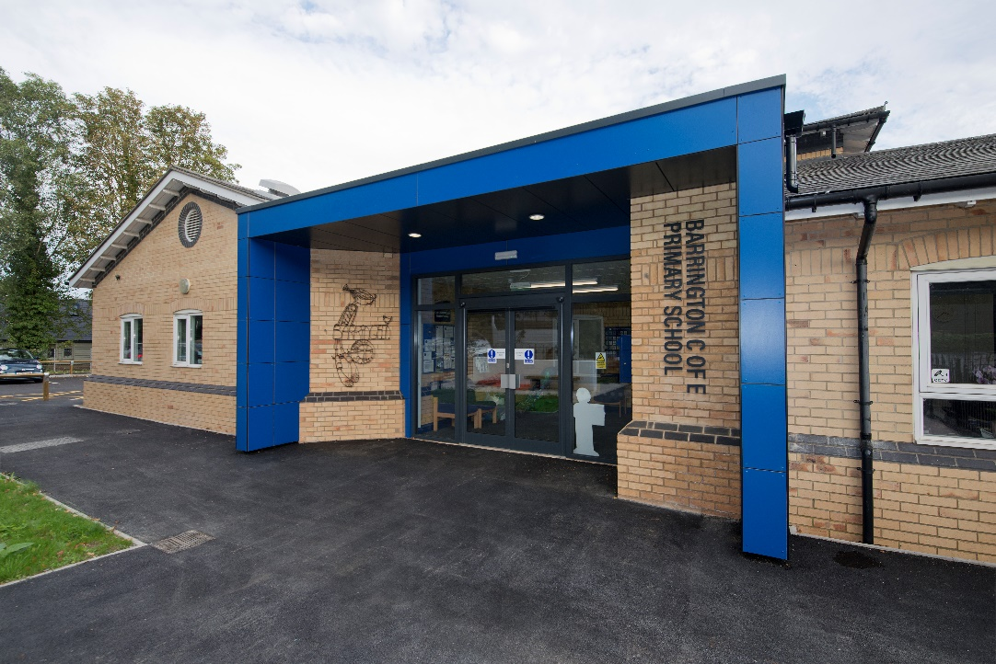

Our School Governors

The Governing Body of Barrington School has the responsibility to provide confident, strategic leadership and to create robust accountability, oversight and assurance for educational and financial performance of the school.

The Governing Body three core functions:
- Ensuring clarity of vision, ethos and strategic direction;
- Holding executive leaders to account for the educational performance of the organisation and its pupils, and the performance management of staff;
- Overseeing the financial performance of the organisation and making sure its money is well spent.

All this cannot be achieved without working closely with the Headteacher and the staff and by having good communication and cooperation with parents, the local authority, the church and all the other people who support the school.

The governors’ job is to assist with the strategic development of the school and to ensure accountability. They do not deal with day-to-day management issues as this is the job of the Headteacher. The Governing Body is made up of representatives from the parents, the staff, the local authority, the church and the local community. Details of the current members of The Governing Body can be found on the school website.

The whole Governing Body meets about twice a term and the various committees meet regularly to discuss particular aspects of running the school, the minutes for these meetings are displayed on a notice board at the school. Governors also make formal visits to the school to look at particular aspects of the curriculum.

Day-to-day matters should be raised with your child’s class teacher or the Headteacher. If you have any queries or issues, please feel free to contact myself or any of the governors c/o the school. If you think you might be interested in joining the Governing Body or would like more information, please let me know.

Helen Cobley (CHAIR OF GOVERNORS)

chair@barrington.cambs.sch.uk

The School Day

School starts at 8.55 am
Playtime: 10.25 am to 10.45 am
Lunch KS1 -12.00pm - 1.10pm (Red, Orange and Yellow Class)
KS2 -12.10pm - 1.10pm (Blue, Indigo and Violet Class)
School finishes at 3.25 pm.

The school opens at 8.45am and children come directly into their classrooms. Children should not be on school grounds prior to 8.45am as no supervision is provided. If you wish to bring your child earlier please book them into the out of hours school club. Registration takes place at 8.55.
At the end of the day children should be picked up from their classroom or on the school playground. Please inform your child and the school of any change of routine i.e. if someone else is collecting your child or they are not going home on the bus.

Transport to School

The school serves two villages and a bus is provided by the Local Education Authority for children travelling from Shepreth. The children are supervised on the coach and escorted on to the school site on arrival at school. The class teacher takes a register of those children travelling home by bus which is checked off at the end of the day by a member of staff. The children are expected to follow a clear code of conduct whilst travelling on the coach.

Safer Routes to School

As a result of involvement in the county’s Safer Routes to School Initiative, there is traffic calming outside the school, a speed limit of 30 mph through the village, flashing lights near the school, a pathway to the rear of the school (which is partially lit) and cycle storage.

There are parking restrictions in force outside the school where parking is prohibited between 8.30am-9.30am and 2.45pm-3.45pm. This is monitored by the police.
Children are encouraged to walk to school as much as possible. Children in Years 5 and 6 are allowed to cycle with their parent’s permission. We recommend that children younger than this are accompanied on their journey to and from school by an adult.

If you do need to drive to school, please use either the car park at the Village Hall or opposite the Church and accompany your children the rest of the way. Please do not use the staff car park for drop off or pick up from school.

Our Home-School Partnership

We believe that the home-school partnership is an essential part of our commitment to success. We see teachers and parents as equal partners working together to enable all children to reach their potential. We hope you will take an active part in your child’s education and welcome the help of parents, carers and grandparents in school.

Parent consultation evenings are held in the autumn and spring terms. At the end of the summer term parents receive a comprehensive report on their child’s progress. However you do not have to wait for these evenings if you have something you would like to discuss with your child’s teacher; we would far rather you came in to see us straight away if you have any questions or concerns.

We endeavour to keep you fully informed of school activities through regular
newsletters and class topic information at the beginning of each term. All school policies are available for reference. Please ask at the school office.

Homework Policy

The Partnership

To work effectively homework needs to be part of a wider partnership between home and school. At Barrington School we have always recognised and valued the part parents and carers play in the education of their child. We also appreciate that children need time after school to relax and pursue their own interests.

The Purpose of Homework

- To encourage an effective partnership between the school and parents and other carers in pursuing the aims of the school.
- To reinforce and extend skills and understanding particularly in literacy and numeracy.
- For children to develop the skills and confidence needed to study on their own.

The Role of Parents and Carers

- To continue to encourage and support children’s learning, through showing interest, providing opportunities and arranging activities.
- To provide a reasonably quiet place in which the children can do their homework.
- To encourage children and praise them when they have completed their work.
- To ensure that work returns to school on the correct day.
- To make it clear to children that they value homework.

The Role of the School

- To inform parents at the beginning of each term about homework timetables.
- To provide guidance for helping children at home.
- To keep a timetable so parents can work out a routine.
- To involve parents in feedback e.g. reading booklets, targets and homework diaries for older pupils.
- All policies are available for reference from the Headteacher.

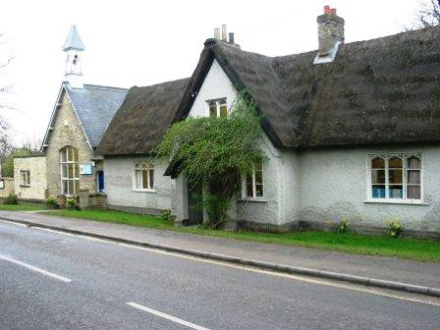

Links with the Community

The school seeks to retain its close links with the community and is always keen to develop these further. We participate in events organised by the community, for example the history society weekend, the church flower festival and the village coronation celebrations. We also hold events in school to which the community are invited, for example the annual Macmillan coffee morning, the school nativity play and summer production by the older children. Local firms and organisations continue to support the school through ‘Friends of Barrington School’ (FOBS) events. For example, Grants have paid for the older children to complete first aid training with the St John’s Ambulance and TTP sponsored the whole school science week. Volunteers continue to run clubs eg for patchwork and the school provides a venue for various after school clubs. Pupils support a number of charities throughout the year, holding various events to raise money.

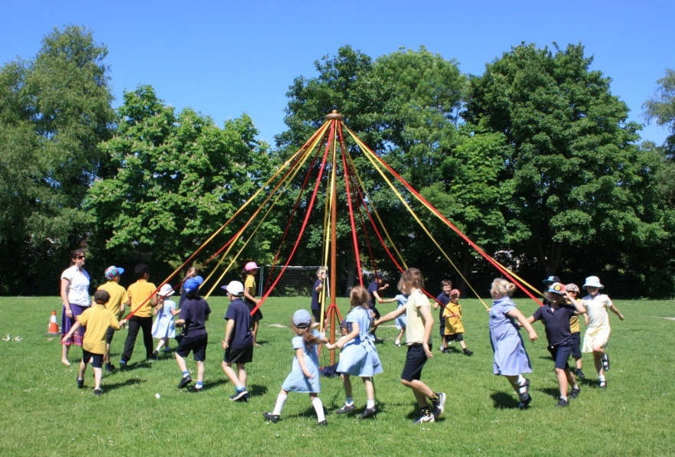

There are, of course, many other ways in which the school and local community work together. Please contact the school if you feel you have a skill, an interest or some time that you would be willing to share with us.

Class Organisation

Barrington School currently has six classes. There are seven year groups in a Primary School, Key Stage 1 (pupils aged 4 to 7 years) and Key Stage 2 (pupils aged 7 to 11 years.) This means that many children will be taught in mixed age classes. Key Stage One are organised into three separate year group classes with a maximum of 30 pupils in each. The remaining three classes will contain Key Stage Two pupils, at least one of these classes will be a mixed age class containing two year groups of children, which class this is depends on the number of children in each year group. The number of children in a KS2 class should not exceed 32. As the children move through the school, they may spend more than one year in some classes. Class composition is carefully considered and criteria such as age, maturity and ability are used to make a professional judgement regarding the best class groupings.
As the school grows over the next few years, we will gradually move to having up to a maximum of seven classes, one class per year group. However, this growth will happen gradually as families move into the new houses.

Admissions

Cambridgeshire Local Education Authority (LEA) is responsible for setting the admissions policy criteria for this school. Parents wishing to apply for a Reception place for their child can apply on-line at www.cambridgshire.gov.uk/admissions or you may contact the school for an admission form. Paper copies of forms should be completed and returned via the school. Parents will be informed in April/May time whether a place is available for their child. Please contact the school or admissions team for dates.

Parents new to the area who wish to see the school during the day should telephone: 01223 712273 to make an appointment. We are always pleased to see parents and welcome the chance to talk with you. We see teachers and parents as equal partners, working together to enable all children to reach their potential

Places will be allocated on the basis of the Published Admission Number (or PAN) for the year group and the admissions criteria set by the LEA. The PAN for Reception at Barrington School is 30 places.

Please contact Admissions Team for the current admissions criteria.
admissions@cambridgeshire.gov.uk 0345 045 1370
Cambridge Admissions Team
Box no CC 1206
Castle Court
Castle Hill
Cambridge, CB3 0AP
Or visit: www.cambridgeshire.gov.uk/admissions

Parents seeking places in other year groups can apply at any time. If there is a place, it will be offered. If the year group is full, the child will be placed on a reserve list and the parents will be offered the right of appeal.

Further information about admissions or appeals can be found in the LEA primary admissions booklet for parents or by contacting: The Admissions Team on 0345 045 1370. Email: admissions@cambridgeshire.gov.uk

Special Educational Needs (SEN)
The children are at the heart of Barrington School and learning and teaching strategies are matched to their individual needs. This includes:
- Ensuring an appropriate classroom learning environment matched to the needs of all pupils
- Highly trained and skilled staff who are experienced in working with children with a wide range of abilities, needs, learning difficulties and disabilities
- The provision of specialist teaching and learning strategies and breadth of resources to match the individual needs every child
- A differentiated curriculum which is matched to the needs of all of our learners
The progress of every child in our school is assessed, monitored and discussed in termly pupil progress meetings between the head teacher and every class teacher. If any child is not making the progress we would expect, this is discussed with parents and support is put into place.
Our school has two special needs coordinators (SENCo), Gill Davies who has completed the National Award for SEN Coordination and Janice Nussey. They are responsible for advising class teachers about the provision they make for children with SEND (special educational needs and disabilities), and for overseeing our whole school provision. They can be contacted by email at head@barrington.cambs.sch.uk or jnussey@barrington.cambs.sch.uk
Equal Opportunities

Barrington School is an inclusive school, we aim to eliminate from the curriculum any bias or stereotyping and we aim to ensure that particular groups of pupils are not disadvantaged in school and to promote their participation and success. These groups may include;

The school completed an Equalities Review in 2022. The policy document and objectives are available on request.

Multicultural Education

At Barrington School we endorse the Cambridgeshire County Council belief that 'Education for All' means providing all pupils with the knowledge, skills and attitudes they need to live happily in their own culture, the main culture and in and across other cultures.

More Able Pupils

At Barrington Primary School we recognise that all pupils have different abilities and aptitudes and we aim to ensure that all pupils excel and develop as much as possible socially, intellectually, creatively and personally. We also recognise that children’s abilities develop at different rates and so seek to avoid labels and any form for ‘ceiling’.
In order to support pupils currently achieving highly in a particular area we will:
• seek to fully engage them in their learning, at a personally appropriate level, which leads to the highest possible levels of achievement and personal fulfilment;
• provide challenging activities and have high expectations across the curriculum;
• aim for a greater depth of mastery within age related national expectations, rather than moving on to coverage of objectives in higher year groups.
• Foster growth-mindset beliefs in the value of hard-work and effort, rather than innate talent.

Higher achieving pupils include those with academic ability as well as those talented in art, music, PE, or any other area of the curriculum, or beyond. We employ a number of strategies to meet the needs of higher achieving pupils but first and foremost these needs are met through quality teaching, effective differentiation of work and personalised feedback. In addition, these children may have the opportunity to access enrichment activities in or out of the school day.

School Liaison

Barrington School places a strong emphasis on close relationships between local primary schools, Melbourn Village College and St Bede’s Inter Church School. We meet regularly to discuss the curriculum, local and national issues and the smooth transfer of children to secondary school. Regular sports matches, musical and arts events are arranged to broaden the children’s experiences and enable them to meet peers from local schools.

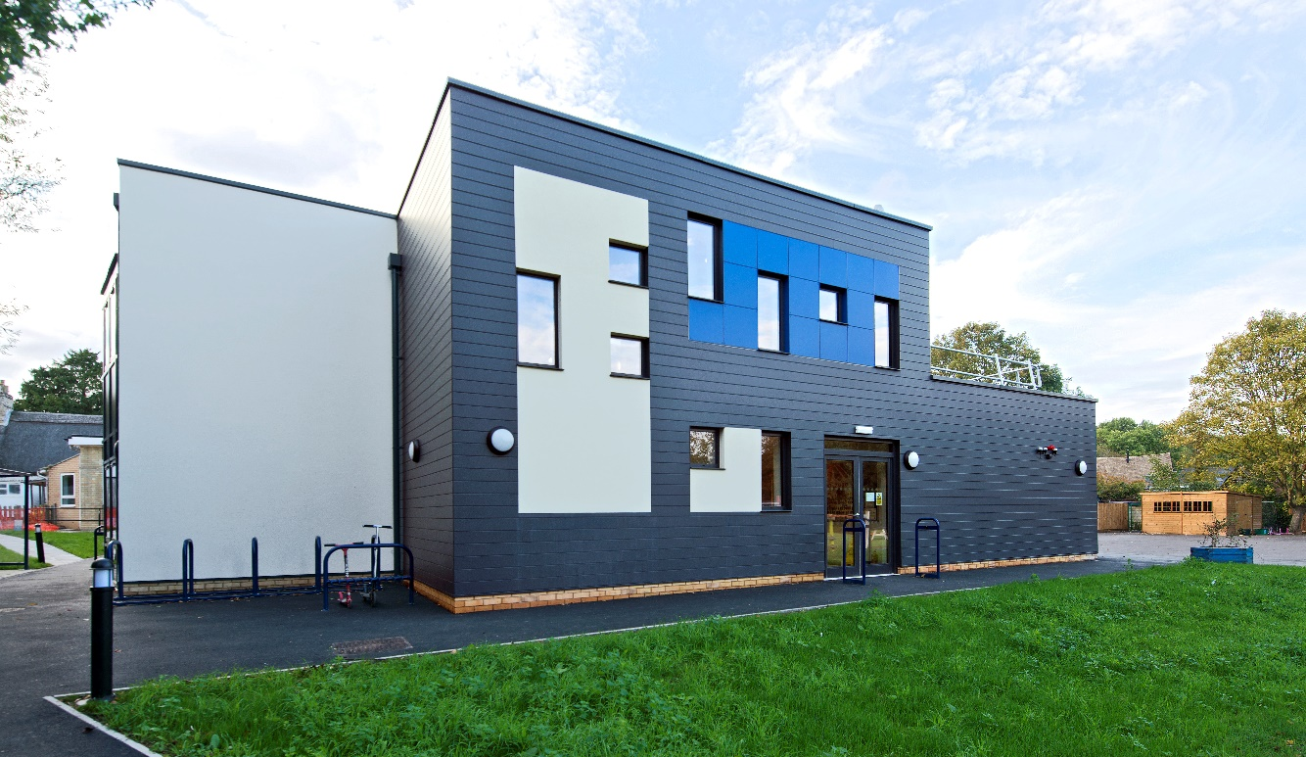

Positive Behaviour

We expect our children to behave in a polite and thoughtful manner to adults and children, thereby creating an atmosphere in which all children feel happy and secure. They are expected to take responsibility for their own actions and possessions in a way that reflects thoughtfulness for the rest of the school population, its buildings and equipment.

We believe strongly in the power of praise and focus on recognising positive behaviour, while instances where children make an inappropriate choice for their behaviour are used as a learning opportunity.

Most problems are usually not very serious and can be dealt with by the supervising adult. We operate a behaviour protocol that applies to all children and is uniformly applied by all staff. A copy can be provided on request. Serious behaviour incidents, such as hurting another child, will result in reflection time with the head teacher or a senior member of staff. A number of minor incidents in one day also result in a reflection time. During a reflection time, we work with the child to talk through why their behaviour needed to be discussed, who was affected by their behaviour, what they could do to make amends and what would be a more positive way to behave in the future.

Serious misbehaviour, e.g. bullying, is brought to the attention of the Headteacher without delay. In such cases, parents will be involved in order that their co-operation can be sought in finding an effective solution. All staff will be informed so that close monitoring of the individual can be maintained throughout the day. In extreme cases, the Chair of Governors will be informed. Exclusion is a measure that, hopefully, will not be necessary at Barrington School. However, should the need ever arise, the Headteacher will take the necessary action and inform the Governing Body and LEA. The school will follow the procedures set out in the school’s Behaviour and Anti-Bullying policies and follow guidelines from the Local Education Authority. All incidents which are racially motivated are formally logged in accordance with Local Education Authority guidance.

Barrington School is committed to ensuring that all staff and adults with responsibility for children’s safety and welfare will deal professionally with all incidents involving aggressive or reckless behaviour, and only use physical intervention as a last resort in line with DFES and Cambridgeshire County Council’s advice. If used at all it will be in the context of a respectful, supportive relationship with the pupil. We will aim to ensure minimal risk of injury to pupils and staff.
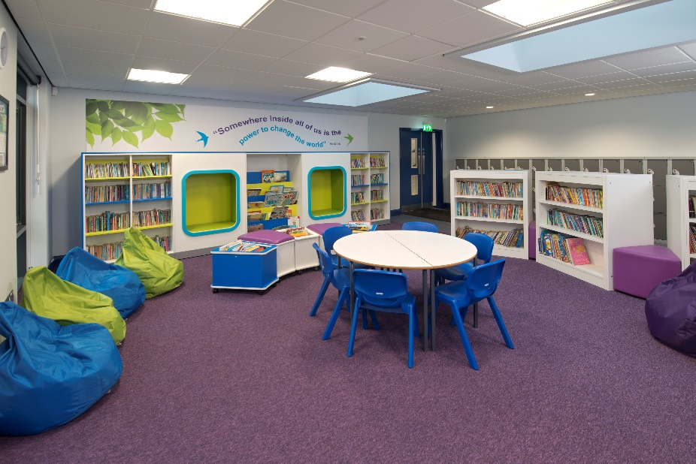

Attendance

Good attendance is crucial for your child to meet their potential. In order to reward excellent attendance, classes compete to have the highest weekly attendance and any class gaining 100% attendance for a week earns themselves an extra 10 minutes playtime. We also reward termly 100% attendance badges and certificates.

If your child is ill during term time, please follow these procedures:-
Telephone 01223 712273 or email the office (office@barrington.cambs.sch.uk) on the first day of absence before 10.00am.

If a child suffers from sickness or diarrhoea, please allow 48 hours to lapse after the symptoms have ceased before returning the child to school.

Please notify school in writing if your child will be absent in order to receive treatment. If your child has to leave school during lesson time for any reason, (e.g. to attend a dental or hospital appointment) please would you put the request in writing and report to the staff in the school office who will collect your child from class.

The average attendance for primary school pupils in England is 96% and the attendance of every child in school is monitored. We receive regular visits in school from the educational welfare officer and they will become involved if a child’s attendance falls below 90%.

The attendance policy is available on request.

Holiday Absence in Term Time

Pupils of school age must, by law, attend school regularly. Leave of absence for a family holiday should be avoided if possible as it can seriously disrupt pupils’ continuity of learning. If you are unable to avoid taking your holiday during school time you will need to inform the school about the proposed absence by completing a holiday form.

Please try to:-
- avoid asking for absence when your child is preparing for, or taking, end of Key Stage tests (during May)
- avoid the beginning of a new academic year when classroom routines and new groupings are established

In accordance with the latest guidance the school does not to authorise absence due to holidays during term time unless there are exceptional circumstances. Any holiday taken in term time will be will be identified and reported as unauthorised absence. It is the policy of Cambridgeshire Education Authority to issue fines for unauthorised absences for more information please refer to Application for Leave of Absence Form.

School has a statutory duty to report the number of authorised and unauthorised absences and receives regular monitoring visits from the educational welfare officers.

School Attendance Officer

There are close links between the school and the School Attendance Officer. Their aim is to help all children (wherever they attend school) to benefit from the education being offered to them.

The School Attendance Officer acts in a liaison capacity building up relationships between school, family and child and education department. They will support, explain and advise on any issues that may prevent a child benefiting from or attending school. Guidance and advice may also be given in respect of free school meals, uniform grants, employment of children bylaws, children in entertainment etc.

The School Attendance Officer, based within the South Cambs District Team at Cambourne, can be contacted on: 01954 286012. A message may be left and you will be contacted as soon as possible.

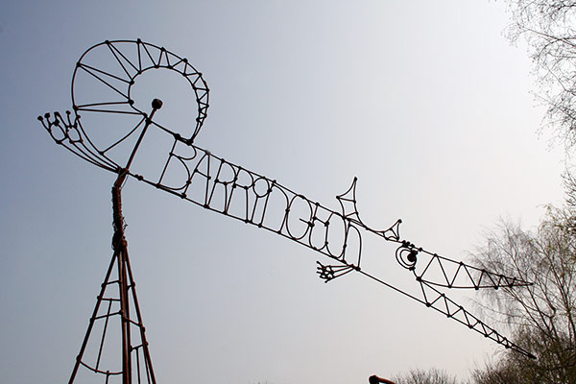

Dinners

School dinners provide an opportunity for the social development of children. Dinner money should be paid for in advance eg for the week on Monday morning. If an emergency arises at home during the week, children may, of course have dinner at short notice. If your child has to leave school after 10.00 am due to illness and has already ordered a school meal, this will still be charged for. The cost of a school meal for KS2 pupils is currently £2.80 (this may rise in September).

We operate an on-line payment system, so school meals and most trips can be paid for online. Please note we are a cashless school, we use School Gateway for online payments for school trips, events and lunches. Peacock club use SCOPAY for booking and payments.

If you have a low income, your child may be entitled to free school meals. Please look on Cambridge County Council website for forms, alternatively please contact the school office. The information you provide concerning free meals will be treated in strictest confidence. Your child may prefer to bring a packed lunch. This should be in a suitable container clearly marked with the child's name. No glass bottles or fizzy drinks please. Please try to support the school’s healthy eating policy. We are a Nut Free school so please no food items containing any nuts.

From September 2014 the government introduced the universal free school meal scheme to all children in Key Stage 1 (Reception, Year 1 and Year 2); you will not need to apply. If however (due to financial circumstances) you would be entitled to free school meals or help with other school expenses, please do apply as this will trigger extra funding which can be used to support your child in a wide range of ways eg school trips and extra support in school. The continuation of Universal Free School Meals for Key Stage 1 pupils is subject to Government legislation and may be withdrawn in the future.

Playtimes

Children are allowed to bring snacks (No Nuts or items containing nuts) to eat at morning break. As a school we would ask you to reinforce our healthy eating curriculum by providing your children with healthy snacks such as fruit (fresh or dried), vegetables etc. Sweets and chewing gum are not allowed in school. We do not encourage children to share their snacks because of the prevalence of food allergies. Children in Key Stage 1 are provided with a piece of fruit each morning under the National Fruit Initiative Scheme.

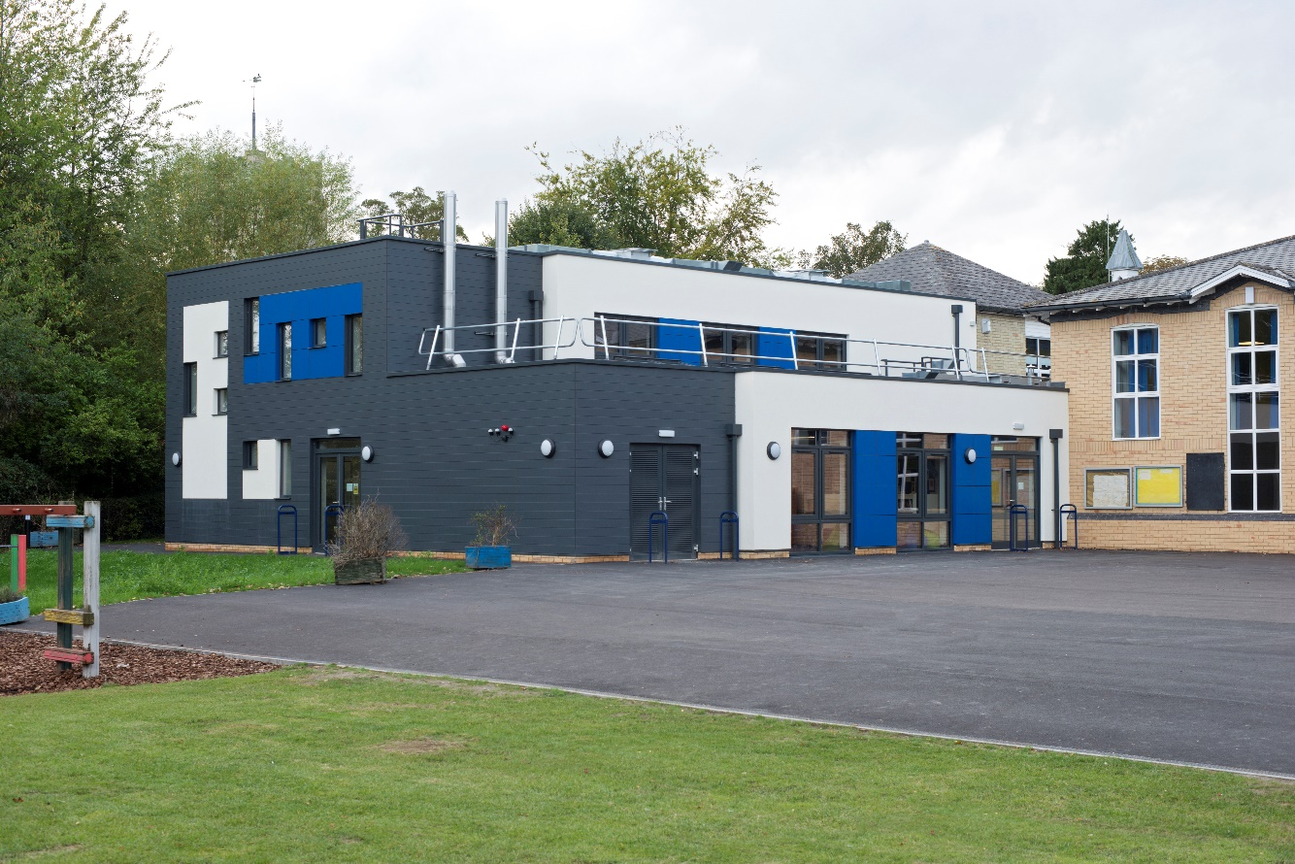

The School Curriculum

The current primary curriculum came into effect on 1st September 2014. The current EYFS 1st September 2021. We deliver the curriculum interwoven with our belief that a creative curriculum is one that engages and excites our learners. Termly plans for each class will be available on our website along with our long term whole school plans. The topics are devised to engage and interest the pupils and also allow teachers to share their interests and areas of expertise. Great emphasis is placed on children learning from first hand experiences. The curriculum policy and subject policies are available on request.

We also run a program of whole school inspiration days linked to the National Curriculum to inspire and motivate the children and give them opportunities to apply what they have been learning. We believe children learn best when they are engaged and having fun. Our inspiration days have included: Thinking Skills, Chick Hatching, Orienteering, Well Being Day, May Day, African Day, Personal Safety week and Science week.

Assessment

The progress of each child is monitored and information is given to parents through reports and regular consultation. Assessment in the early years is undertaken as the children play and interact with adults. From Year 1 upwards, pupils undergo formal assessment each term. For all children progress between each term is carefully monitored to ensure that every child reaches their potential. Informal and on-going assessment takes place throughout the lessons. The assessment policy is available on request.

Key Stages

Foundation Stage or EYFS refers to pre-school aged children and in those in their Reception year.
Key Stage One (KS1) refers to children aged 5 - 7 years. (Years 1 & 2))
Key Stage Two (KS2) refers to children aged 7 - 11 years. (Years 3, 4, 5 & 6))

Foundation Stage

Children in Reception Year follow the “Foundation Stage” Curriculum. The curriculum is divided into seven areas of learning:

- personal, social and emotional development;
- communication and language
- mathematics
- literacy
- understanding the world
- physical development
- expressive arts and design

Early Learning Goals establish expectations for most children to reach by the end of the foundation stage. They are organised into the 7 areas of the curriculum and provide the basis for planning throughout the foundation stage, laying secure foundations for future learning. By the end of the foundation stage, some children will have exceeded the goals, others will still be working towards some or all of the goals.

We believe that children learn best when they feel secure and are interested in what they are doing. They also learn well when they are engaged in practical activity, enquiry and purposeful play. They can consolidate their learning by practice, talk and reflection. We aim to teach the children to be independent in their learning. The habits established in the early years provide a foundation for their future education.

In order that the children are familiar with school, we invite them to attend a number of sessions during the summer term. We also liaise closely with the local playgroups and nursery schools. Parents also have an opportunity to meet with the Headteacher and class teacher before their child starts school. Children are usually inducted into school life on a part-time basis in the September.

English - Language and Literacy

During your child’s first year at school communication and language development involves giving all children opportunities to experience a rich language environment; to develop their confidence and skills in expressing themselves; and to speak and listen in a range of situations.
Literacy development involves encouraging children to link sounds and letters and to begin to read and write. They are given access to a wide range of reading materials (books, poems, and other written materials) to ignite their interest.

From Years 1-6 a typical lesson consists of whole class input from the teacher to introduce the theme, genre and Learning Objective of the lesson. The teacher will use a range of strategies to engage the children, including drama, reading a text together, watching extracts from videos, discussing prior knowledge and predicting to name a few. The teacher will demonstrate what is expected of the children through modelling and questioning, before setting the children off on tasks which may be led by the teacher, teaching assistant or working on their own. The lesson may end with a plenary where good work may be shared, opportunities for the children to check and correct their work and opportunities to extend their learning.
Throughout the year children will be introduced to a range of fiction, non-fiction and poetry.
Handwriting is taught, first forming letters using correct orientation and spacing, and from Year 2 cursive script is introduced.
Spelling, punctuation and grammar is taught discreetly from Year 2, and elements of SPaG is included in English lessons, Guided Reading tasks and Phonics in Foundation Stage and Key Stage 1.

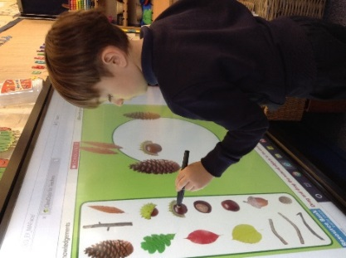

Mathematics

Maths involves providing children with opportunities to develop and improve their skills in counting, understanding and using numbers, calculating simple addition and subtraction problems; and to describe shapes, spaces, and measures.
In every lesson we ensure regular and consistent coverage of the National Curriculum aims: to ensure that all pupils become fluent in their use of numbers, can reason mathematically and can solve problems. During the main focus of the lesson we encourage all pupils to engage with real problems; guessing, discovering, and making sense of mathematics.

Science

Science will be taught as a single subject or part of a wider theme. It is taught as knowledge and the investigation of wider concepts.

Key Stage 1
Science, as with most areas of the curriculum, must start with the child's known environment and experience. The children are encouraged to use their senses exploring, sorting and grouping objects in the immediate environment. They begin to be aware of similarities and differences and learn to record their findings in a variety of different ways.

Key Stage 2
As children get older their understanding of the world in which we live increases. Logical thought is promoted and a greater depth of understanding is expected. Children begin to design their own experiments to test ideas. The need for fair testing will be developed. Children will work in a variety of grouping encouraging them to consider carefully how they will communicate their findings to others.

Computing

Each class has an interactive whiteboard, which makes it possible to use ICT throughout the teaching and learning in the school. The children have access to computers, netbooks and i-pads to support their learning as needed in every class.

We see the computer as another educational tool, linking in with as many areas of the curriculum as possible. The children use the computers in a variety of ways, for word processing, internet research or accessing online games and apps to support their learning in lessons.

As part of the 2014 curriculum, children will also use computers to write simple computer programs and de-bug them. They will also be taught about e-safety – how to use the internet safely.

We are connected to broadband internet through the Local Education Authority and follow the county and national guidance on internet safety.

Design and Technology

Key Stage 1
Children will need to explore familiar situations, artefacts and systems in order to develop an awareness of design and technology. They will learn to recognise that a wide variety of materials are used to design and make things. They will have opportunities to explore various materials in order to discover their different properties. They will be taught the skills which enable them to join materials and use equipment safely.

Key Stage 2
As the children progress they will be encouraged to identify their own tasks for design and technology. They will use the experiences of Key Stage 1 to make more complex products. Knowledge and skills from other subjects will support this work.

Planning will be more detailed and the use of tools appropriate to the materials. They will be encouraged to consider procedures that minimise waste and achieve accuracy and quality. Pupils will be asked to review their planning and justify their decisions. They will be asked to discuss ideas with peers and to work individually and in a variety of different groupings

Religious Education

Religious Education takes its place alongside all the other subject areas of the curriculum in playing a part in the personal, social and moral development of the child. We use the Cambridgeshire Agreed Syllabus throughout the school as a basis for Religious Education provision and the requirements of the 1988 Education Reform Act. There are two aims: the first is to enable pupils to acquire knowledge and understanding of Christianity and the other principal religions represented in Great Britain. The second is to develop the pupils’ ability to explore, reflect upon and to respond to human experience, drawing upon their study of religion.

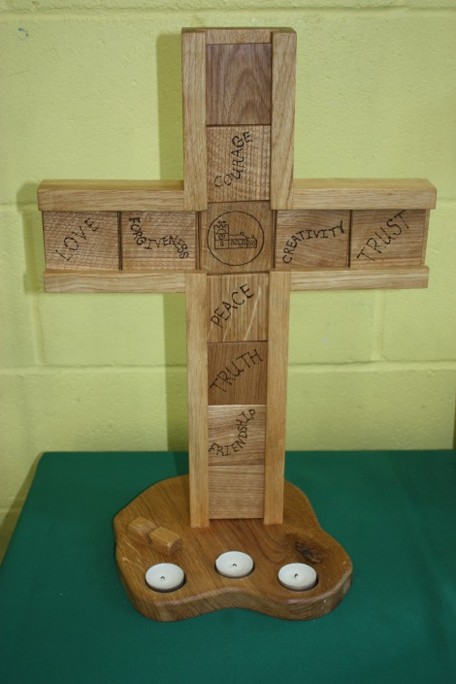

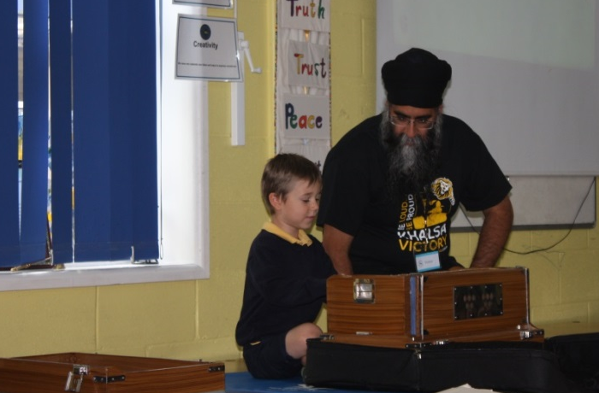

Withdrawal from Religious Education
RE is intended to be suitable for all pupils in the county's schools. It benefits pupils by increasing their understanding and awareness of other people and their ability to respect the rights of others even where they disagree with their views. It contributes to pupils' spiritual, moral and ethical development. It is designed to be of educational worth to pupils from any or no religious background.
Very occasionally a parent may wish to exercise the right to withdraw their child from all or part of RE. In this case the school might wish to try to discuss the matter with the parents to make sure that their request is based on a clear understanding of what RE involves, and to make practical arrangements for the supervision of the child. It is a legal requirement that the right of withdrawal should be mentioned in the school brochure. Teachers similarly may exercise the right of withdrawal, but in such a case schools must ensure that provision is made for all pupils to receive the RE that is their entitlement.
Further information may be obtained from:
The General Adviser for Religious Education : Amanda Fitton
Contact for SACRE:
Laura Corcoran - SACRE Clerk for Cambridgeshire and Peterborough
Email: Laura.Corcoran@peterborough.gov.uk
Mobile: 01480 379 668

Collective Worship
Collective Worship, which takes place in accordance with the Christian faith, forms an important part of the life of Barrington School. There is an act of worship every day and it takes place in a variety of forms and locations. It is the right of parents to request that their pupils be withdrawn from Christian religious assemblies. Parents wishing to exercise this right are requested to do so in writing to the Head Teacher. Parents must be aware that for the duration of collective worship the pupil will need to work on appropriate tasks without direct supervision by the class teacher.
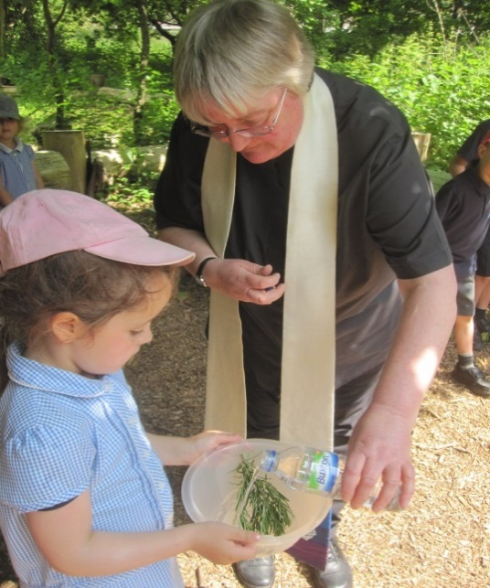

History
Key Stage 1
At KS1 children are helped to develop an awareness of the past through stories from different periods and cultures. They focus on the lives of significant individuals and distinguish between recent history and more distant events.

Key Stage 2
At KS2 children are taught about important events, individuals and developments in Britain’s past, from the Stone Age to modern times. They also learn about ancient civilisations and the history of the other parts of the world. The children study the local history of Barrington and Shepreth through various themes. Historical enquiry skills and chronological understanding are developed rigorously in order for children to begin to understand how primary and secondary sources are used to interpret the past.

Geography

Geography is concerned with the study of places, the human and physical processes which shape them and the people who live in them. Geography helps children to make sense of their immediate surroundings and the wider world

Key stage 1
Much of KS1 geography will be based on direct experience, practical activities and exploration of the local area. Pupils will use maps, pictures and books to compare Barrington and Shepreth with other places. The children will be introduced to the vocabulary of geography and be encouraged to ask geographical questions.

Key Stage 2
At KS2 children will develop their understanding of geography by studying a contrasting locality and a locality in an economically developing country. They will be taught how to find geographical information and develop skills to help them interpret and make sense of the knowledge gained.

Music

The children meet a variety of composers and instruments throughout both key stages. They have the opportunity to play a range of melodic and rhythmic percussion and tuned musical instruments from around the world. Children have opportunities to listen to a wide range of music in order to develop their knowledge of styles, dynamics and tones, as well as to give children an appreciation of many types of music. They compose their own pieces in groups or as a class, then listen and evaluate their performances.

Children in Key Stage 2 are currently given the opportunity to learn an instrument taught by our own music specialist, Mrs McGregor. This enables the children to gain experience of reading music, tuning instruments and play in an ensemble.

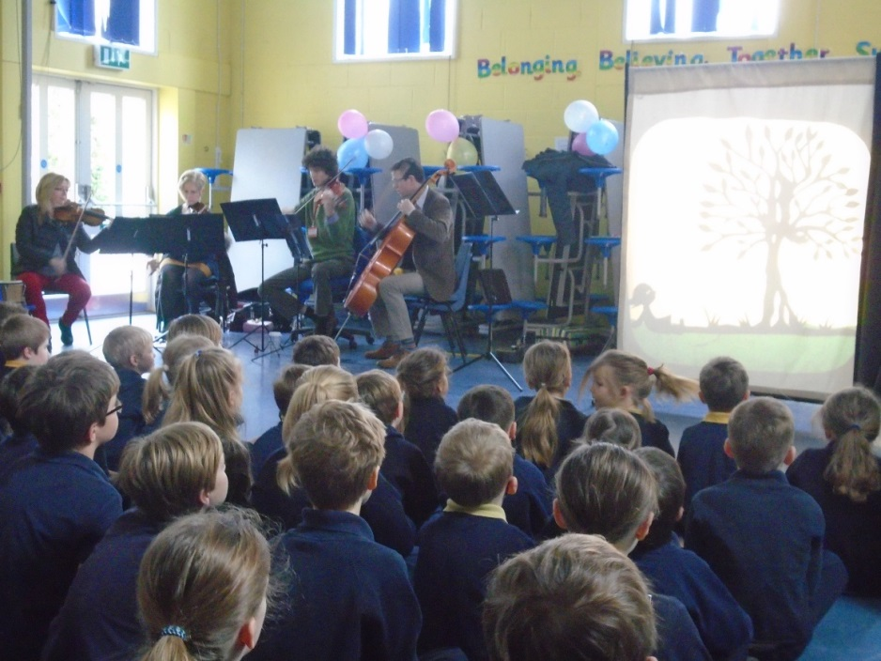

All children have the opportunity to sing regularly in class lessons, in key stages (Key Stage 1 Nativity play, Key Stage 2 Summer Production) or in whole school choral worship weekly.

Art and Design

The children meet with a wide range of means towards artistic expressions including painting, drawing, modelling, collage, fabric work and printing. They also have the opportunity to become aware of some of the world’s major artists. The children's work is displayed around the communal areas of the school. Creative expression is a deep human need and education has a duty to help children satisfy it.
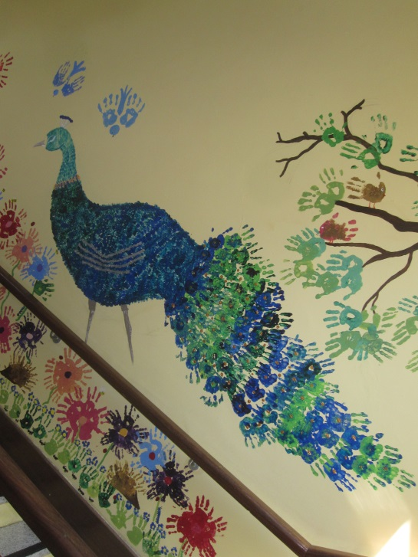
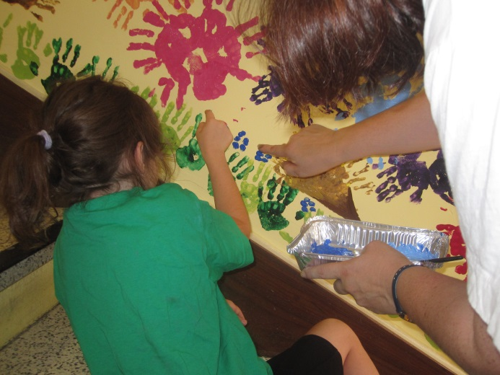

Physical Education

Physical education occupies an important position in the primary curriculum. As children develop physically they need to explore their capabilities and potential. Alongside this, there is a need for children to gain understanding of movement and spatial awareness. In addition, children need to come to an appreciation of the value of co-operation in team games. Children are involved in sports matches with local schools. KS2 children have the opportunity for swimming lessons at Melbourn Leisure Centre as part of the PE curriculum. There are several clubs run after school.
All physical education is delivered by a specialist coach, Mr Johnny Herd. The work is carefully planned with the school and assessments are conducted each term.
The children also learn dance and this is delivered as part of their topic work and through our programme of inspiration events throughout the year.

Every year we receive some government sports funding that we must use for sport and PE. Our PE funding is being used to develop the quality of the PE provision throughout school and details of how it has been spent and the impact it has had can be found on our school website.

Personal, Social and Health Education and Citizenship (PSHE)

Our school philosophy is based on creating an environment in which individuals feel valued and where personal endeavour and responsibility for themselves and others is nurtured. PSHE. is fundamental to this. Children are involved in activities that will give them the skills to work constructively in groups and to make and sustain relationships with peers and others and keep themselves safe.

Sex and Relationships Education

This key area is studied under the umbrella of Personal Social and Health Education, which together with Science, provides a natural and caring environment for learning about growing and changing, both physically and emotionally. Parents are always given the opportunity to discuss the details of the programme and become familiar with it before it begins.

The Relationships and Sex Education policy was developed by a working party of teachers, parents and governors and ratified by the Governors. If you would like to see a copy of the full policy, please contact the school office.

Parents have the right to withdraw their children from all or part of the sex education outside of the National Curriculum. A parent wishing to exercise this right should in the first instance make an appointment to see the Headteacher. Any parents still wishing to exercise this right should write to head teacher at the beginning of each academic year.

Modern Foreign Languages (MFL)

In Key Stage Two the children have a weekly lesson from a language specialist from Melbourn Village College and in line with the foreign languages that the children will learn when they move to secondary school, they are currently taught Spanish.

Health and Safety

The governors of Barrington School recognise and accept their responsibilities for the establishment and maintenance of Health and Safety and ensure, so far as is reasonably practical, the Health, Safety and Welfare of our staff, pupils and any visitors to our premises.
Pupils are expected to exercise personal responsibility for the safety of self and classmates; observe standards of dress consistent with safety and/or hygiene (this would preclude unsuitable footwear, jewellery and other items considered dangerous); observe all the safety rules of the school and in particular the instructions of staff given in any lessons or in an emergency and not wilfully misuse, neglect or interfere with things provided for his/her safety.

Complaints about the School Curriculum

Under the provision of the Education Reform Act 1988 schools are required to inform parents of the procedure for dealing with complaints about the school curriculum.

Stage 1

The parent should first address a complaint or concern to the class teacher who will usually be able to resolve most problems.

Stage 2

If the problem has not been resolved to the parent's satisfaction the complaint should be taken to the Headteacher who will acknowledge receipt within five days. The Headteacher will endeavour to resolve the problem and record the complaint, the outcome of subsequent discussions and any advice given.

Stage 3

If the parent feels dissatisfied with the outcome of Stage 2 the complaint should be given in writing to a governor who will contact the chair or, in their absence, the vice chair. An acknowledgement of receipt of the complaint will be sent to the parent within three days, explaining who is dealing with the complaint and when they may expect a full reply (which should normally be sent within 10 days). If a consultation is required with other agencies such as Education Welfare, the school doctor etc. and a full response will not be possible within 10 days, the letter of acknowledgement will explain the reasons for an extended response time and an indication of when a full response will be made. The governors' full response letter will also make it clear that the parent can finally appeal by contacting the educational helpline co-ordinator.

Stage 4

If after the governors' letter the parent is still dissatisfied, parents or carers can contact Cambridgeshire County Council general enquires helpline by telephoning 03450 455 200. They will advise you where your concern can most appropriately be considered.

We hope all complaints can be resolved at the first stage and encourage anyone who has a concern about their child's progress to discuss the matter with the child's class teacher.

Key Stage Test Results

At the ages of 7, 11 and 14 children take National Tests. Teachers also use their knowledge of the work children have done to judge the children’s progress. This is called teacher assessment. Children are assessed as to whether they are meeting Age Related Expectations (ARE) in Reading Writing and Maths.
Due to the small size of our cohorts and the large percentage of our overall data that each child represents our data is subject to more fluctuation than in larger schools.

Due to the COVID-19 crisis there were no National Assessments during the summer terms of 2020 or 2021 and attainment for children across the country has been impacted by the disruption to their learning caused by the pandemic.

School Results
EYFS
The table below shows the percentage of children achieving a Good Level of Development (GLD) at the end of their first year in school. The GLD is a measure of attainment at the end of the EYFS (Early Years Foundation Stage). Children are deemed to have achieved GLD if they have achieved the ELG (Early Learning Goals) in the EYFS curriculum areas of Personal, Social and Emotional Development, Physical Development, Communication and Language Development, Literacy and Mathematics.

 | Percentage of children achieving a Good Level of Development (2017) | Percentage of children achieving a Good Level of Development (2018) | Percentage of children achieving a Good Level of Development (2019) | Percentage of children achieving a Good Level of Development (2022)
Barrington | 73.68% | 93.8% | 81.8% | 91%
National | 69.2% | 71.5% | 71.8% | 65.2%

Y1 Phonics check

The table below shows the percentage of children at Barrington that pass the phonics check administered to Y1 pupils.
 | Working at  % | Working towards  % | Did not take phonic check  %
2022 | 86.4% | 13.6% | 0
2019 | 94.1% | 5.9% | 0
2018 | 82.3% | 17.7% | 0
2017 | 76.9% | 23.1 | 0

KS1

Assessment results are no longer reported in terms of levels of achievement. Assessment results in both KS1 and KS2 are now reported in terms of whether children have met the age related expectations (ARE).

 | Reading | Writing | Maths
2022 | 75% | 69% | 76%
2019 | 78.6% | 57.1% | 64.3%
2018 | 64.3% | 57.1% | 78.6%

KS2

 | Reading | Writing | Maths
2022 | 66.7% | 33.3% | 73.3%
2019 | 50% | 68.75% | 62.5%
2018 | 86% | 86% | 79%

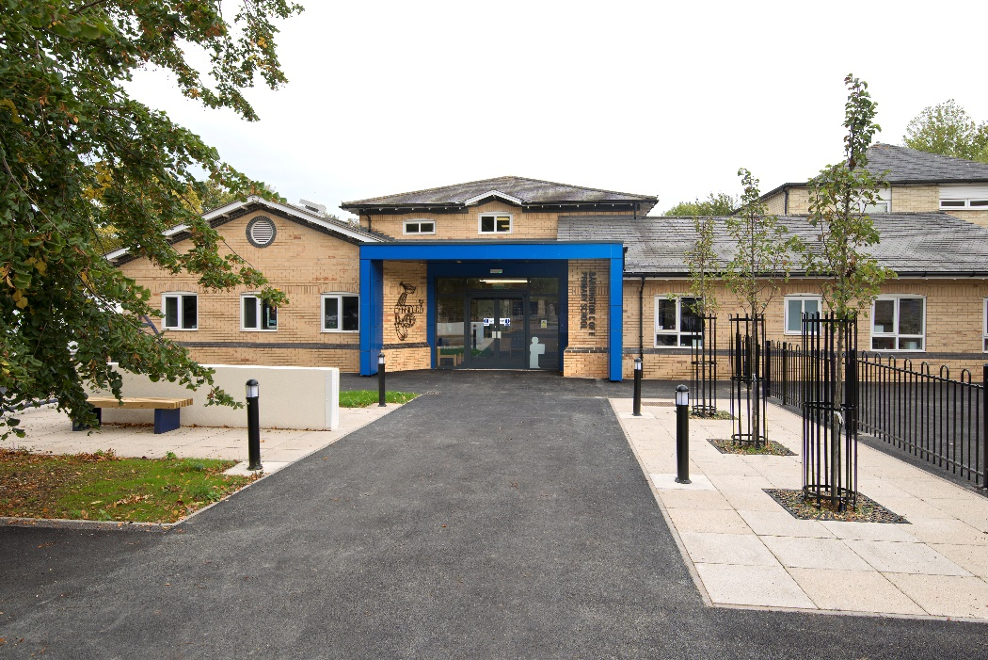

Ofsted - The school’s most recent inspections took place in April 2022 and 2017.

Both were short inspections, with the findings were presented in the form of a letter addressed to the head teacher, which we have included here.
Ofsted 2022

Inspection dates: 28 April 2022
Outcome Barrington C of E VC Primary School continues to be a good school.

What is it like to attend this school?
Pupils at Barrington Church of England Voluntary Controlled Primary School are confident, kind, and happy. Pupils enjoy their learning and can concentrate. Ducklings in the corridor were an exciting focus for learning even at play time. Organised trips bring learning to life for example, visits to a sustainable farm, a local river trip and going to the seaside. These all provide valuable learning experiences for pupils.

Pupils routinely behave well. They say that bullying is rare, and any incidents are quickly dealt with. Pupils feel valued. This is because their voice is heard, and their ideas are included in the life of the school. This is through the many varied ‘ministries’ that pupils can be part of. For example, having a role in designing areas of the school like the library. Pupils have a wide range of clubs that they can take part in. This is in addition to the ministries, for example, netball, choir and multi-sport.

Pupils are respectful active citizens. They show tolerance and understanding of others. For instance, when talking about what it might be like to be a refugee. One pupil said, ‘I just want to give them (a refugee) a hug’.

What does the school do well and what does it need to do better?

Leaders have carefully considered the curriculum particularly when responding to having both single- and mixed-age classes. The curriculum thinking has taken into account the knowledge pupils need to learn at every stage in every area of the curriculum.

Staff implement the leaders’ intended curriculum effectively. Staff use their secure subject knowledge to check pupils’ understanding and address any mistakes or misconceptions. Any pupil who is falling behind is quickly identified and support is put in place to address any gaps. As a result, pupils remember what they have been taught and are able to apply it to learn more.

Reading has a high priority across the school. This is shown by, for example, the school’s newly designed library and the expansive range of rich texts. Pupils enjoy their reading and talk animatedly about books they have read in school and at home. Leaders give parents lots of ideas to help them to support their children with their reading. Most staff are well trained to use leaders’ chosen approach to phonics well. In the early years, children quickly pick up the skills they need to begin their journey to becoming confident and fluent readers. Leaders have systems in place to monitor the progress that pupils are making with their reading. These identify pupils who need extra support. Still, support put in place to help the few older readers to catch up is not having the impact that leaders intend.

Pupils with special educational needs and/or disabilities (SEND) access the full curriculum alongside their peers. Leaders accurately identify the needs of pupils with SEND. Plans are well considered to ensure that they are able to learn effectively.

Parents and pupils are closely involved with the plans that are put in place. This helps parents to support their children effectively. Pupils have many opportunities to develop themselves beyond the curriculum. For example, supporting the elderly by writing to them during the lockdown, and partaking in a national singing event in an arena.

The curriculum content teaches pupils to empathise with others. For example, opportunities to raise money to support children’s education in other parts of the world. These experiences ensure that pupils are very aware of differences and are able to show respect, tolerance and understanding to others. They also give pupils the confidence to have a go at the different opportunities that are available to them, such as going on the school residential.

Governors know the school well. This ensures that all leaders, including governors, have a shared vision for school improvement. Governors carry out their safeguarding duties effectively.

Safeguarding

The arrangements for safeguarding are effective. Staff understand their responsibility to safeguard pupils. This includes carrying out the appropriate checks to ensure that all adults are suitable to work with pupils. Regular and specific training helps adults to understand and identify the risks pupils face. This helps staff to be vigilant about looking out for signs of harm. Adults know how to report a concern. Leaders take swift action in response to any concerns raised. This includes involving other agencies where needed.
The curriculum ensures that pupils learn about how to stay safe online, as well as what steps they would take if they had a concern.

What does the school need to do to improve? (Information for the school and appropriate authority)
◼ While the teaching of phonics and early reading development is strong in key stage 1 and early years, staff in key stage 2, and, in particular, those staff that carry out interventions for weaker readers, are not as secure in their knowledge of phonics. Support for older pupils who struggle to read is less effective. As a result, these pupils do not achieve as well. Leaders need to ensure all staff are well trained, so they are able to support weaker readers to catch up quickly.

Background
When we have judged a school to be good, we will then normally go into the school about once every four years to confirm that the school remains good. This is called a section 8 inspection of a good or outstanding school, because it is carried out under section 8 of the Education Act 2005. We do not give graded judgements on a section 8 inspection. However, if we find evidence that a school would now receive a higher or lower grade, then the next inspection will be a section 5 inspection. Usually this is within one to two years of the date of the section 8 inspection. If we have serious concerns about safeguarding, behaviour or the quality of education, we will deem the section 8 inspection as a section 5 inspection immediately.
This is the second section 8 inspection since we judged the school to be good in January 2017.

Ofsted 2017
Dear Mrs Davies,
Short inspection of Barrington Church of England VC Primary School

Following my visit to the school on 17 January 2017, I write on behalf of Her Majesty’s Chief Inspector of Education, Children’s Services and Skills to report the inspection findings. The visit was the first short inspection carried out since the school was judged to be good in September 2012.

This school continues to be good.

The leadership team has maintained the good quality of education in the school since the last inspection.

In the short time since you were appointed as the substantive headteacher in September 2016, you have maintained a strong focus on ensuring that pupils fulfil their potential. You have high aspirations for the school, and these have been shared with staff and the governing body and are well understood. Staffing changes have been managed well so that they have not negatively affected pupils’ learning.

You lead the school in a calm and purposeful manner. You have strong relationships with staff, pupils and parents and are committed to ensuring that the school’s motto, ‘Belonging, Believing; Together Succeeding’, is reflected in all aspects of its work.

You have effectively identified the strengths and weaknesses of the school. You know that to continue to improve you need to ensure that pupils always do as well in writing as they do in reading and mathematics. You agree that by sharing more widely the responsibility for checking the provision, development planning can be better focused on the main priorities. This will help staff and governors take a fuller part in securing improvement.

There is a delightful atmosphere in school. You and your staff go the extra mile to make sure that school is not only about learning in lessons. You provide a wide range of clubs which make school exciting and fun. Older pupils said they greatly enjoyed a recent residential visit where they learned new skills such as orienteering.

You ensure that pupils understand the importance of good behaviour and this is reflected in their conduct throughout the school day. Pupils give each other good support when working. At playtimes, older pupils take great care when playing to ensure that the youngest are kept safe and happy.

Pupils are proud of their school. They happily celebrate each other’s successes. They reflect thoughtfully in assemblies about how they can help others. Class ambassadors take their responsibilities very seriously. They took great care, when talking to me, to explain what their class was learning and what their role involved. This is a good example of how you enable pupils to become confident and self-assured individuals.

With good support from the governing body, you and your predecessors have successfully tackled weaknesses from the previous inspection. You have given parents more information so that they are able to do more to support their children with learning at home. Parents are very positive about the school’s work. They typically make comments such as, ‘every day is simply a pleasure for my child’ and ‘the school is very well run, it is friendly and supportive of both children and their parents.’

You have improved the mathematics curriculum since the previous inspection. Pupils are especially positive about the teaching of mental mathematics. They say that recent changes are helping them ‘to think more quickly when working out a calculation’.

Safeguarding is effective.

The governing body and other leaders have ensured that safeguarding arrangements are fit for purpose and that appropriate and detailed records are kept. You have established a culture where pupils’ safety is given the highest priority. Pupils are very clear that they are kept safe. They have a good awareness of the dangers they may face in later life. They talk confidently about how to use the internet safely. For example, they know what to do if they receive a message on social media from someone they do not know.

Leaders make sure that training for staff takes place regularly and that they receive updates routinely. Staff have a good awareness of how to respond to concerns if they have any. Their responsibilities in this area are well understood. Records show that any concerns are dealt with quickly.

Inspection findings

- At the start of the inspection, we agreed to focus on some key lines of enquiry. The first of these was pupils’ progress in English, especially of boys. We chose this focus because attainment in reading and writing, especially in key stage 1, was lower than in mathematics, with boys attaining less well than girls. You have already identified writing as your key area for improvement and I agree that further work is needed in this area. School data shows that, while progress for both boys and girls in writing is good most of the time, it is more uneven than in reading or mathematics. This is because teachers do not always expect enough of pupils, sometimes accepting work that is not their best. We agreed that pupils, especially boys, could take more care with their writing so that it is neat and tidy and check completed work to avoid making careless mistakes in spelling and punctuation.
- As part of this key line of enquiry, I heard some pupils reading. Pupils make good progress in reading. They read frequently for a wide range of purposes. The most able express preferences for authors or genres and read with good expression. Less-able pupils confidently use their knowledge of phonics to read unknown words.
- We also looked at provision in the early years because the proportion of children reaching the expected level of development at the end of the Reception Year fell in 2016. You and the early years staff were able to explain the reasons for this. It is clear that, while outcomes were lower than usual, this was due to lower starting points rather than weaknesses in provision. I saw that children are happy and settled in the Reception class and learn well most of the time. However, as elsewhere in the school, progress is not always good enough in writing. Teachers give children too few opportunities to practise and reinforce writing skills.
- The third key line of enquiry focused on provision for pupils who have special educational needs and/or disabilities and for the disadvantaged. We agreed to look at this because few of these pupils reached the expected level for their age by the end of Year 2 or Year 6. I found that provision for these pupils is effective. School assessment information, as well as work in pupils’ books, shows that they make good progress from often lower starting points. You work well with parents, pupils and teachers to ensure that pupils’ work and the support they are given are well matched to their needs.
- Together we examined, as a key line of enquiry, the rigour of school self-evaluation and how well it feeds into development planning. I was concerned that your development plan was unclear about the main targets for improvement. I found that you know the school well. However, staff and governors are not sufficiently involved in evaluating the school’s work so that they can help you to identify the most important priorities from year to year and ensure that they are reflected in development planning.
- As part of the inspection focus on safeguarding, we checked the attendance of disadvantaged pupils and those who have special educational needs and/or disabilities. Historically, these pupils have attended school less frequently than others. I am reassured that you are dealing with this effectively. Current attendance information shows that your work with outside agencies is having a good effect. This has already resulted in improved attendance in the current year.

Next steps for the school
Leaders and those responsible for governance should ensure that:
- teachers always expect enough of the pupils when they are writing and, in the early years, there are more opportunities for children to practise and reinforce their writing skills
- pupils take care to present their written work neatly and check it for errors carefully
- staff and governors are more involved in self-evaluation so that development planning can be focused on the most important priorities.

I am copying this letter to the chair of the governing body, the director of education for the Diocese of Ely, the regional schools commissioner and the director of children’s services for Cambridgeshire. This letter will be published on the Ofsted website.
Yours sincerely
Mike Capper
Ofsted Inspector

The full report of previous inspections are available online on the school or Ofsted websites or please ask at the school office for a copy.

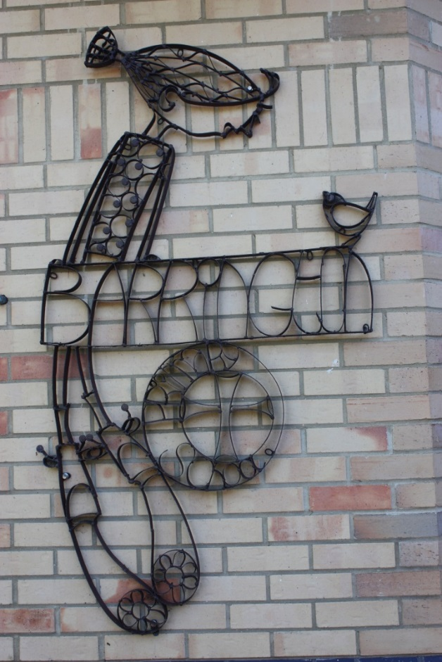

School Activities

Barrington School is able to offer several additional activities that enrich the children’s experiences and enable them to pursue special interests.

Visits and Extended Trips
The Governors see school trips as an essential part of the children's education. They provide the opportunity for children to extend and consolidate classroom activities with first-hand experience. Where these are part of the curriculum there is no legal obligation for parents to contribute other than on a voluntary basis. No child will be left out of an activity because his or her parent cannot make a contribution. However, in the event of insufficient funds being raised we retain the right to cancel those visits or activities. We also use the local area to support our curriculum activities and this involves children leaving the school premises in organised groups during the school day. We may not send out a note each time this happens but will inform you if special arrangements need to be made.

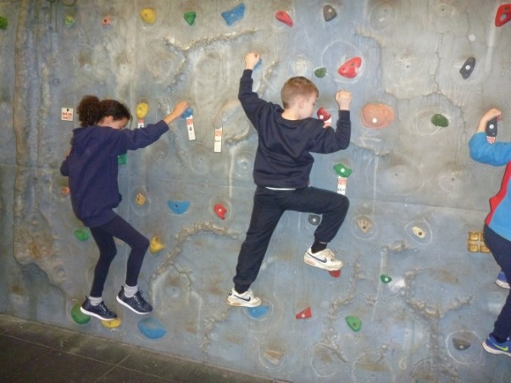
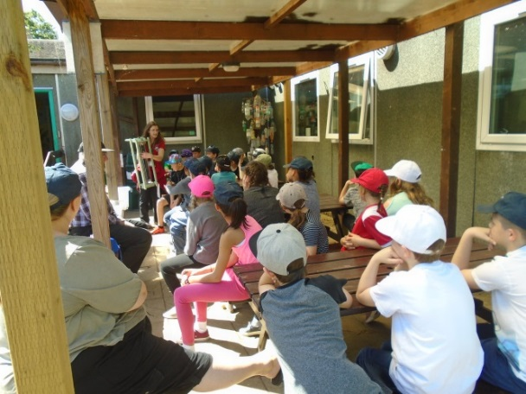

The older children take part in an extended trip to one of the local residential centres. Help from qualified staff is sought for all specialised activities. Funds are available to help parents who might find this financially difficult and an application form is available from the office in strictest confidence. Parents receive information in advance of all school trips.

Pastoral Care

Safeguarding and Child Protection Statement

Parents/carers should know that the law requires all school staff to pass on information which gives rise to a concern about a child’s welfare, including risk from neglect, physical, emotional or sexual abuse. Parents/carers should know that records of safeguarding concerns may be kept about their child. They should be informed that school staff will seek, in general, to discuss any concerns with them including referrals to other agencies.

Local procedures state that “Consent should always be sought from an adult with parental responsibility for the child/young person before passing information about them to Children’s Social Care, unless seeking consent would place the child at risk of significant harm or may lead to the loss of evidence for example destroying evidence of a crime or influencing a child about a disclosure made.” This includes allowing them to share information without consent, if it is not possible to gain consent, if it cannot be reasonably expected that a professional gains consent, or if to gain consent would place a child at risk.

Where there is a need to share special category personal data, the Data Protection Act 2018 contains ‘safeguarding of children and individuals at risk’ as a processing condition that allows professionals to share information.

In accordance with legislation and local Information Sharing protocols, we will ensure that information is shared securely and sensitively. Information will only be shared with other services where it is deemed necessary and proportionate to ensure that children and young people are safe and receive the right service. In all circumstances, the safety of the child will be the paramount concern.

Schools will contact Children’s Social Care when they have reasonable cause to suspect a child may be suffering or likely to suffer significant harm. Occasionally, concerns are passed on which are later shown to be unfounded. Parents/carers will appreciate that the member of staff in the school with responsibility for child protection (known as the Designated Safeguarding Lead or Deputy Designated Safeguarding Lead) was carrying out their responsibilities in accordance with the law and acting in the best interests of all children.

Under Section 3 (5) of the Children Act 1989, any person who has care of a child “may….do what is reasonable in all the circumstances of the case for the purpose of safeguarding promoting the child’s welfare”. This means that on rare occasions, a school may need to “hold” a child in school whilst Social Care and the Police investigate any concerns further.

The child protection policy is available on request.

At Barrington School a ‘Volunteer Register’ is kept and as a matter of due process all adults who volunteer to help with children will be police checked in accordance with the latest guidance.

Looked After Pupils –

Children and young people become “Looked After” either if they have been taken into care by the local authority, or have been accommodated by the local authority (a voluntary care arrangement). Most Children Looked After will be living with foster parents but a smaller number may be in children’s residential units, living with a relative or even be placed at home with their birth parents.
Since the White Paper ‘ Care Matters’ of July 2007 the term “Children in Care” is also in use.
It is nationally recognised that, for Looked After Children, there is considerable educational underachievement when compared with their peers as and this governing body is committed to implementing the principles and practice as outlined in: https://www.gov.uk/topic/schools-colleges-childrens-services/looked-after-children/latest
Our Looked After Children policy is available on request.
Photography

There will be occasions during the school year where parents will wish to take
photographs or make a video recording of their child taking part in a school activity such as school assemblies, school performance, sports days, school outings and educational visits. At Barrington School we aim to take practical steps to ensure that pictures and images taken of our pupils are done so in a way that reflects the protective ethos of the school.

In order to do this we need to ensure that parental use of photography and video is monitored and protected for the benefit of our children and parents. In order to ensure that as far as possible parent/carers’ use of photography and video is safe, we implement these procedures:

Parents/carers are asked to sign a photograph/video permission form when they start school, giving permission to use photographs/video of their child for a list of named purposes.

This form includes a section where parents/carers sign to indicate that any images they take of school activities will not be used inappropriately. This will ensure that parents/carers are aware of their responsibilities in this matter. Unless a parent has specifically requested for their child not to be photographed by other parents/carers, then photography and video shall be allowed. We will however ask parents/carers to sign a dated record book for each event if they wish to take images stating that the photographs and video are for their own personal use and not for publication.
If the school receives a specific written request that photographs and video are not to be taken, then the school will respect that request and a blanket “no photography” rule will be set for the event the child is in.
Those children who do not have permission to appear in public documents will not have their photographs published.

Accidents in School

In the event of an accident we will act in the manner of a responsible parent. Most members of staff have been first aid trained.

In the event of a more serious accident or illness every effort will be made to contact the child's parents or guardians. If we are unable to do so we will contact the child's G.P. In the event of an emergency the emergency services will be contacted.

Immunisations

It is important to make sure that immunisations are given at the correct times, and that an accurate record of these is kept. These records will be needed from time to time during the school career of your child. If you are at all concerned about the immunisation programme please contact your family doctor.

Child and Family Nursing Service

Cambridge Community Services will manage queries, provide support and where necessary signpost callers to appropriate services. If you have any concerns about your child’s health please contact on the School Nursing Duty Desk on 0300 029 5050 which is staffed by a School Nurse Monday – Friday 9.30am – 4.00pm during term time.

Email: ccs.cambs.hcp.schoolnursingdutydesk@nhs.net

Head Lice

If you do discover that your child has head lice, please seek medical help from either, your GP, Pharmacist or the school nurse.
In order to prevent outbreaks of head lice, it is sensible to inspect your child's hair at least once a week and to encourage them to brush or comb it well twice a day. Current medical advice is to only use chemical treatments if you child actually has live, crawling lice and not just the egg cases attached to the hair stem. More advice can be sought from the Child & Family Nursing Service. It is not necessary to be absent from school if being treated.

Diseases Caught by Children

You will be fortunate if, during your child's school career, none of the more common diseases is caught. Parents often ask advice on school absence in such cases. Listed below are the recommendations of the Cambridgeshire Health Authority. This is only a guide and it must be stressed that if you are in any doubt whatsoever, you must consult a doctor.

DISEASES | INCUBATION PERIOD | MINIMUM ABSENCE FROM SCHOOL
Chickenpox | 11 - 21 days | Until all spots have crusted over
Diphtheria | 2 - 5 days | Until bacteriological examination is clear
Food Poisoning | 2- 24 hours | 48 hrs & Until clinically fit
German Measles | 14 - 21 days | 5 days from onset of rash
Mumps | 15 - 21 days | 5 days from onset of swelling
Severe sore throat | 2 - 5 days | Until appropriate treatment has been given
Whooping cough | 7 - 10 days | 5 days from commencement of antibiotic treatment
Measles | 10 - 15 days | MINIMUM of 4 days from onset of rash
Diarrhoea and sickness | 48 hours from time of last episode of diarrhoea or sickness

PLEASE do not send any child back to school just because the minimum period of absence has finished, if they are not fully fit.

School Uniform

We have a school uniform and encourage children to wear navy blue and yellow, the Barrington School colours. Wearing school uniform plays an important role in helping children feel part of the school. Parents are requested to send their children to school in clothing that is comfortable and appropriate for all activities

ALL CLOTHING SHOULD BE CLEARLY MARKED WITH THE NAME OF YOUR CHILD

We also require that long hair should be tied back.
The following items are available from our school uniform suppliers:
(Plain items without a school logo can be purchased from other suppliers).

The Uniform Embroidery Service is My Clothing and clothes can be ordered online directly from them. Their website is: www.myclothing.com

- Navy blue sweat-shirts with embroidered Barrington logo.
- Yellow or navy polo shirts with embroidered Barrington logo.
- Navy blue cardigan with embroidered Barrington logo.
- Navy blue fleeces with embroidered Barrington logo.
- Navy blue trousers, or shorts for summer.
- Navy blue pinafore or skirt and blue or yellow gingham summer dress.
- PE – Navy shorts and pale blue T-shirts with Barrington logo.
- Book Bags (Navy with School logo) and a drawstring PE Bag
- A sun hat is required for summer.

Children may wear a watch and ONE pair stud earrings if parents consider them responsible enough to do so. Earrings MUST be removed for PE for your child’ safety and children must be able to remove their earrings for themselves. Please note that nail polish is not allowed to be worn at school.

Shoes
It is essential that children wear sensible shoes for school. Shoes should be well fitting and appropriate for the weather conditions. Well-fitting and securely strapped sandals are acceptable in the summer. Please note that Crocs, flip flops etc are not suitable for school due to the number of injuries sustained by pupils wearing them.

PE/Games Kit

Pupils will need plimsolls or trainers for P.E., they must have a change of shoes for PE lesson and not wear their school shoes. Navy/black shorts and a plain yellow or pale blue T-shirt / Barrington Logo T-shirt. Jogging bottoms are a useful addition for outside PE in the Autumn/Winter Term.

This equipment should be kept in a named PE bag and retained in school.

In order to comply with health and safety regulations all stud earrings MUST be removed before P.E. activities and long hair tied back. Your child may not be allowed to take part in some PE if earrings are not removed.

Lost Property

Please label all school clothing clearly with your child’s name to enable us to return lost items quickly. Any unclaimed or unnamed clothing will periodically be donated to charity.

Children’s Personal Property

School cannot accept responsibility for the loss of children’s property. It is advised that valuable or precious items should not be brought to school. In the interests of safety only ONE pair of small stud earrings can be worn in school. Pupils are not permitted to bring mobile phones, or any electronic devices to school.

The Friends of Barrington School

The Friends of Barrington School is an organisation made up of parents, teachers and anyone else who has the school’s best interests at heart! The FOBS committee is made up of parents and teachers who volunteer to be on the committee for a year when we have our Annual General Meeting in September. Thereafter we meet about once every half term usually very informally over coffee and biscuits! If anyone feels that they are too busy to be on the committee but would still like to help out whenever possible, we keep a ‘helpers list’ of those who don’t mind being called upon to help serve tea and mince pies perhaps after the Christmas concert or to do a stint on a stall at our annual fete in the Summer.

‘FOBS’ aims to raise money to provide the school with ‘extras’ not provided by the Local Education Authority, and also to organise social events so that the families and friends of the school can get together and enjoy themselves without the emphasis always necessarily being on fund-raising.

FOBS is a registered charity so we are able to reclaim tax on cash donations. Every penny raised is spent on improving the learning, sports or leisure facilities available to our children.

We depend upon the support and involvement of our parents for our success and are very grateful for the help and commitment given by those who have helped both during this year and in previous years. We would also be really pleased to welcome new members of FOBS and hear your ideas and suggestions for our future.

The Peacock Club – before and after school childcare

The Peacock Club is before and after school childcare run by the school, named by the children after the peacock from Barrington Hall who was often seen wandering in the school playground. It is open daily, in term time, and is mainly staffed with personnel who the children already know form other roles in school. The manager of the club is Mrs Dulcie Cambridge who is a HLTA (higher level teaching assistant) based in school.
Morning sessions run from 7.30 until 8.45 and the children are then taken to their classrooms. Afternoon sessions run from 3.25 until 6.00pm. Sessions need to be booked in advance and booking forms can be found outside the school office and on the school website.

The club is staffed by a play leader and/or a play worker every session. There is always a member of staff on duty with paediatric first aid training and all members of staff have basic first aid training. Every evening there are a range of activities organised and some nights have a particular focus; so Wednesday is ICT night and Thursday night is cooking night.

Senior staff at the Peacock Club hold food hygiene certificates and all the staff have completed Prevent Training. All Peacock Club staff have basic child protection training and full DBS clearance. The SENCo for The Peacock Club is Gill Davies.

The aim of the Peacock Club is to provide the children with a safe and relaxed place to play after school. We aim to ensure every child feels happy, safe and secure, allowing them to learn and develop freely in a play centered environment. We encourage positive relationships and high standards of behaviour and celebrate similarities and differences and promote equal opportunities

