Early Years Foundation Stage
Autumn 2024
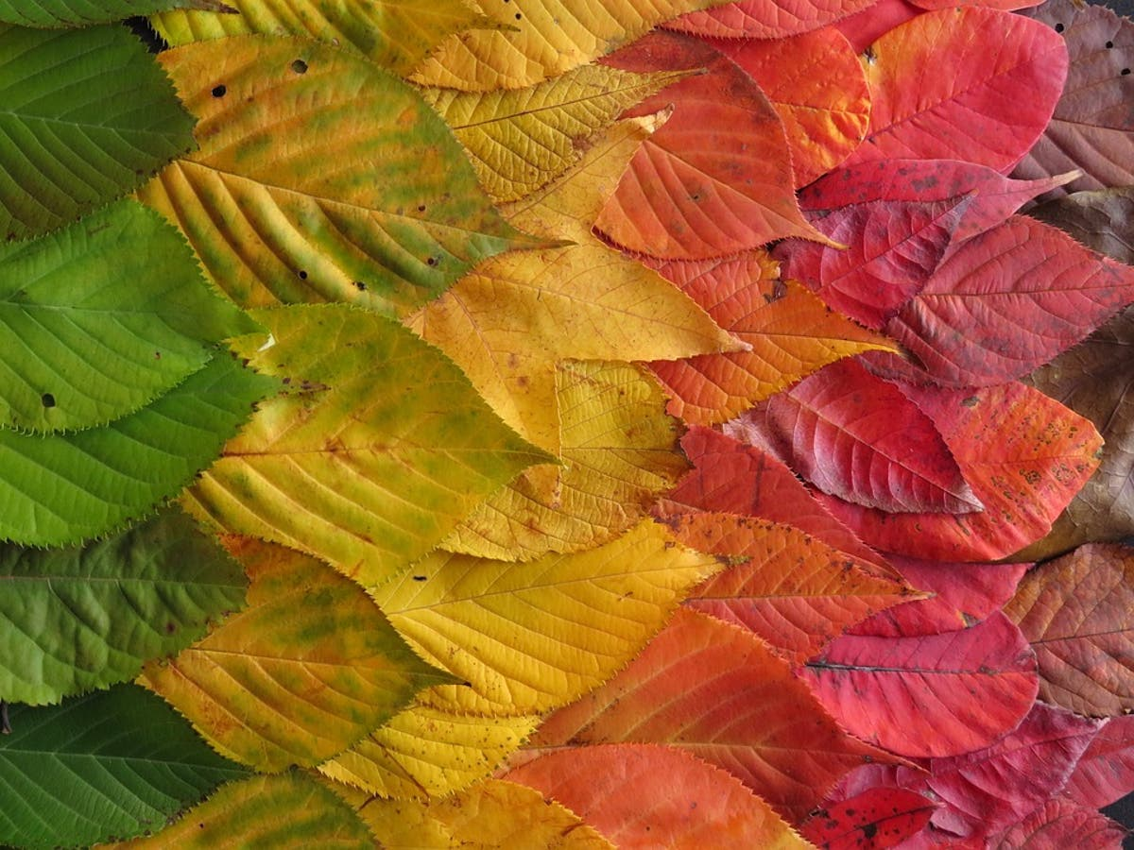
Save the date – How we teach your child to read information evening. Thursday 17th October at 7-8pm in Red classroom.

Welcome to our half termly information letter. In this letter we hope to inform you about topics your child will be covering this term and some ideas as to how you can help your child at home. Our main topic this term is ‘Colour, pattern and Autumn.’

Literacy
Comprehension –Our key texts this term will be, The Dot, Stanley’s stick and We’re Going on a Leaf Hunt. We will use these texts and re-read nursery rhymes to build up confidence in word reading, fluency and understanding and enjoyment.
Vocabulary development – we will be widening the children’s vocabulary in relation to our topic.

Word reading and writing - We will be introducing the children to our phonics scheme, ‘Song of Sounds’ and teaching them the rhymes and songs associated with the letters of the alphabet. We will be learning to read and write and recognise individual phonemes, blend them together when reading and segment words into individual phonemes when we are writing.
This term we will be focusing on the following phonemes: s, a, t, p, i, n, m, d, c, o, g, k, ck,.
This term we will be focusing on the following tricky words: I, the, no, to, go.

Oracy – we will be learning to take turns in a conversation and ask and answer questions.

Mathematics
Number and numerical pattern

We will be focusing on a number each week, starting with 1. Your child may be able to recognise higher numbers. However, we will be digging deeper into their understanding of lower numbers first. For example, when we look at number three, we would like the children to be able to do the following things:
- Make an accurate set of 3 items using various objects.
- Write the number 3.
- Know that if I have 3 items, I also have 1 and 2 in that set.
- Know where to find it on a number line and which number comes before and after.
- Be able to use 3 objects and work practically to find out that 3 is made up of 1,1 and 1 more, 2 and 1 more and 1 and 2 more.
- Know that a shape with 3 side is a triangle.
- Know what 3 o clock looks like.
- Make 3p using 1p and 2p coins.

In maths we will be ordering items in terms of size, and length.
An important indicator of children’s future development in mathematical understanding is their ability to recognise patterns. Therefore, we will be doing a lot of pattern making starting off simple using two colours, e.g., red, blue, red, blue etc. Then we will progress onto red, red, blue, red, red, blue and then using three colours.

Understanding of the world
The Natural World
- To learn what is in our school environment and know where to find what or who they want.
- Join in with forest schools and start to learn about the natural environment.
- Learn about the seasons.

People and Communities
- Similarities and differences between themselves and their friends.
- Know that all families are different.
- Know who is there to help them in and out of school.
- Make new friends.

RE
- To begin to learn about why God is special to Christians.
- To know learn about Harvest and why this is a special time in the Christian church.

Past and Present
- How are the seasons changing?
- Making observations about the natural world and how this affects us.

Expressive Arts and Design
Creating with materials
- Pencil, paint and pastel – learn techniques for using correctly and explore colour, shape and pattern when creating pictures of themselves, animals and different leaves.
- We will study the natural work of Andy Goldsworthy and James Brunt.
- Use various tools and materials to create drawings and models.

Performing
- Songs about harvest.
- Reciting nursery rhymes and poems.
- Recognising quiet and loud and long and short notes.
- Playing to a steady beat.

Personal, social and emotional development and British Values
- Beginnings and belonging – we will be looking at how we are all the same and different and how our actions can make the classroom a happy place.
- My emotions – developing emotional literacy and being able to describe how they feel using a range of language.
- Rules – class and school rules – why are they important?

Physical development
Gross motor skills - Mr Herd our PE specialist teacher will cover
- Gymnastics – movement, balance, agility and coordination.
- Games – Ball skills
Fine motor skills – We shall be developing your child’s fine motor skills through a variety of activities. We will be developing their ability to use pencils, paintbrushes, scissors and cutlery.

During your child’s first half term in school, they will be undertaking a national baseline assessment which is a requirement for all children who have just started school. This will take place on a one-to-one basis, with myself, and alongside other continual assessments, will enable me to plan specific activities to develop your child’s learning. Here is a link to the governments baseline guidance for parents.

https://www.gov.uk/government/publications/reception-baseline-assessment-information-for-parents

Could you please check to see that your child’s clothing are all labelled. As part of our cross curricular work, we will be going to the woods behind school. We will be starting this very soon so keep a look out for an email looking for volunteers to come with us. We will be going regularly on Thursday mornings, if you are free, please let me know. Please ensure that your child has a warm coat and suitable footwear in school for these visits.

Please can you start to send in named PE kits, wellies and a coat in case it is drizzly at playtime.
I will soon be sending out an invitation to join class dojo. This is a free online platform which is secure where I can post photographs of your child’s work.
Feel free to send in a piece of fruit or vegetables (packets of raisins, carrot sticks, cucumber etc…) for your child for morning playtime. We do provide fruit but if they have a favourite, you can send it in. We ask you not to send in items such as cereal bars, crisps, bread sticks etc.

Finally, if you have any worries or concerns please feel free to see me before or after school. If this is difficult for you please phone, if I am unavailable, leave a message and I will contact you.

Clair Hayes
Red class teacher

chayes@barrington.cambs.sch.uk

